Instructions for “One_VAT_App-Straumann”

**Please read and follow all the instructions for a proper use of the application!**

## Pre-requisites:

1. **Purchases & Sales Journals received from client software:**

* 1. Please make sure that each line will have the corresponding tax code
  2. Check if there are any blanks in the column “VAT Registration No.” (only for Romanian and EU company). For any other companies (e.g: NON EU), the app will automatically add an Registration Number (e.g: US1111)
  3. Check if the Registration number is correct and respect the international standard (Country code (2 letters) + numbers)
  4. Delete every row below the last transaction line (select the entire rows and delete them)
  5. Create a new excel file, with three tabs:
     1. Sales Ledger Tabs with sheet name “Sales”
     2. Purchases Ledger Tabs with sheet name “Purchases”
     3. Company info with sheet name “Other info”

1. **Company info should be filed only one by the user with all data and updated if any data changes occur in the next period (Other info template):**



## Instructions:

1. Access the server at [Tax (vatappmirus.azurewebsites.net)](https://vatappmirus.azurewebsites.net/) and select “VAT Apps –Straumann” webapp from portal:

1. In the next page shown below, please enter the details and insert the file presented above (Journals and Company Info):

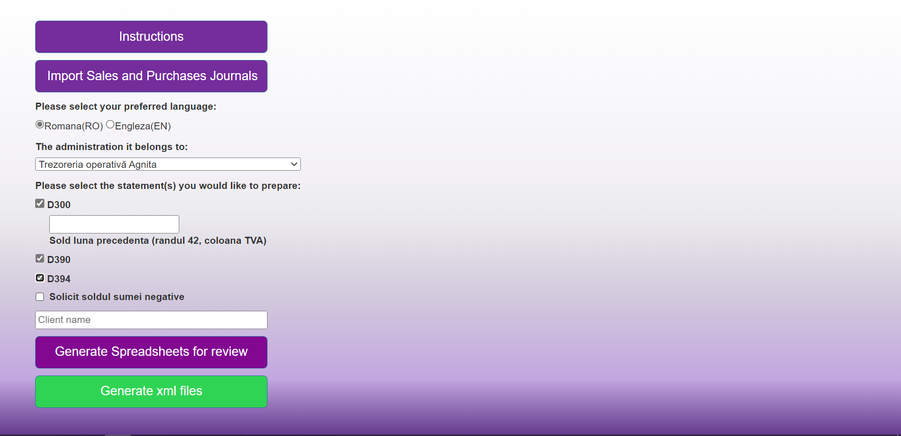

1. Enter the client’s name, select the language, select the administration.
2. Select the statements you would like to prepare: D300/D390/D394
3. Click “Import Sales and Purchases Journals” and import the Journals combined with Company info.
4. Click “Generate Spreadsheets for review”. Once clicking that, the robot will save the spreadsheet in the download folder.
5. App will generate an Excel Spreadsheet document named “One VAT app spreadsheets” + the name of the client.
6. Please review the Excel Spreadsheet named “One VAT app spreadsheets” and save it. Note that every change in the file will be transposed into the statements (XML file).
7. Press the button “Generate xml files” and will open the below page:

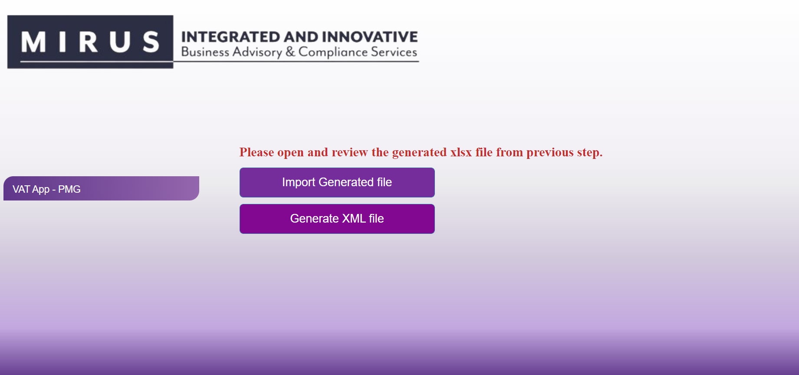

1. In the button “Import Generated file“, insert the reviewed Excel spreadsheet obtained on the step 7 and press the button “Generate XML file” to download the statements.
2. App will send a zip file “arhiva VAT apps” which contains the statements (D300/D390/D394) in XML format (300/394) and TXT format (390).
3. Please validate the xml file for D300 &D394 in DUKintegrator.
4. For D390, please import the TXT file using the import button from the D390 PDF, as presented below:

**For any issues, questions and/or suggestions, please contact:**

**Bogdan Constantinescu,** [**bogdan.constantinescu@ro.gt.com**](mailto:bogdan.constantinescu@ro.gt.com)